|  |
| --- |
|  |
| OAuth 2.0 framework |
|  |
| Identifying the authorization steps |

May 4, 2020

**SLIIT**

Authored by:

H.W.Y.K Geethanjana-MS19810638

S.A Koggalahewa-MS19810010

Dabare A.P.U-MS19808062

**1. Introduction**

In a network traditional communication is done with use of the client-server authentication model.Normaly client request can access restricted resources or protected resources on the server after authencation granted by server using the resources owners credentials. To get the third party applications access to protected resources, sharing its credentials with a third party crates new problems and limitations

* While using third party application it’s needed to store resources owners credentials for future needs.eg:- store passwords in clear text
* While granting the permissions to third party applications it can gain more access to what they require in resources owners resources. This may cause resource owners in vulnerable position without ability to restrict durations or access to a limited resources.
* Servers should provide and support password authentication whether what level is the password security.
* Resource owners cannot remove or revoke access permissions on one third party application without changing the access levels on all third parties.

Because of these problems for authentication, OAuth framework is introduced. OAuth 2.0 give solution to above problems by adding a new layer called authorization layer. This new authorization layer is separate the client form the owner(resource owner).In OAuth framework when client sends requests ,resources are released by the resource owner and hosted in the resource server.

Oauth 2.0 is a protocol that is used in industry standard uses for authorization. This Framework primarily focuses on simple and specific authorization methods for different applications and platforms such as mobile phones/portable living room devices, web applications and desktop applications.

General Oauth 2.0 framework has following flow to specific roles

* Resource Owner: Give access to protected resources. Examples end-user.
* Resource Server: API that user needs or access. This server host the resources(protected)
* Client: Application that requesting the protected resources, behalf of the Resource Owner. In this step User needs to give permission to access protected resources.

**2. Process**

The report describes the steps of uploading a file to Google Drive with the Google Authorization. To begin the process, the application requires a Client ID and a Client Secret which are obtained from Google API Console. After obtaining the above two components, application could make a request to Google Authorization Server by introducing the new application itself. Then Google Authorization server requests the login details. After providing the valid login credentials, an access token will be granted from the Google Authorization Server.

The Following Scenario describes the Google Oauth in more detail

Resource Owner (End-User)

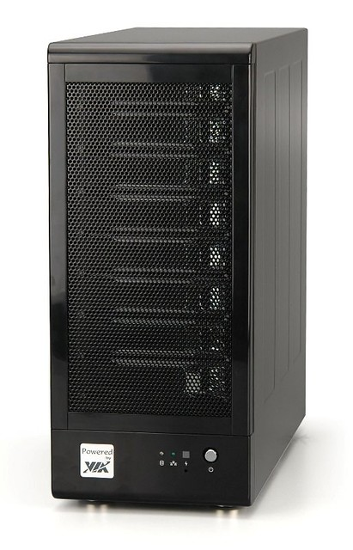



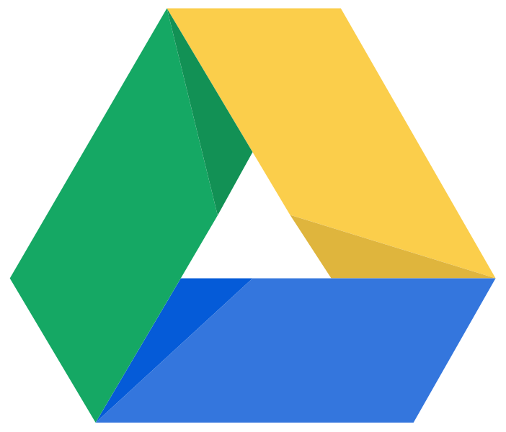

My App

Resource Server (Google Drive)

OAuth Server

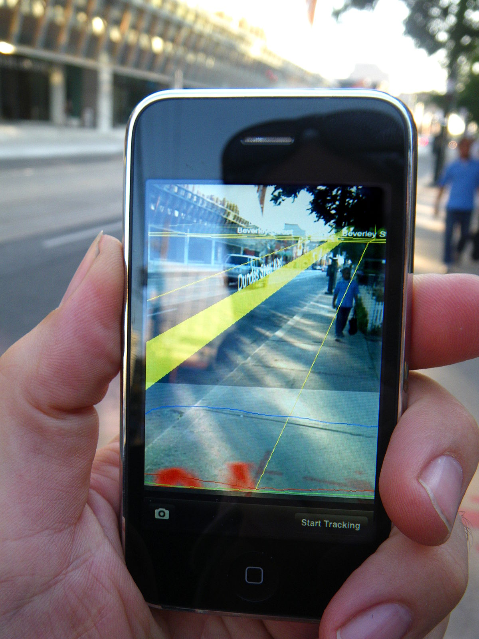

*Figure:*

Figure 1 depicts the main components of the application “Oauth”. The main components are described in the following section.

1. Resource Owner (End user)

2. Oauth Server (Google Oauth Server)

3. Resource Server (Google Drive Service)

4. Client Application

Client application contains the client id and client secret which are obtained from the Oauth server. As the first step, Client app (My App) sends a request to Oauth server to obtain the access of the Resource server by providing its client ID.

After receiving the access request from the application, Oauth server requests the resource owner for authorization. In this scenario a login screen will be prompted to the resource owner (end user).

After resource owner has granted the permission, the Oauth server will generate an authorization code and send it to my app (client application).

In the next phase, Client application sends the client id, client secret and authorization code to the Oauth Server for application validation. After validating the above three components, Oauth Server creates an access token. Then the myapp receives the generated access token and store it in the application. Usually this access token is valid for a certain period. (Days or hours)

Resource server allows the direct access of its resources when the client application requests the access with a valid access token.

Hence the developed Google file uploader program consists of two phases.

* Get Client id and client secret from Google cloud platform
* Develop client-side application

**Step 1: get API from Google cloud platform**

Google supports common oauth 2.0 protocol. The first step to get an API from Google is to initialize a new project in Google API console. The project is named as SSLRGoogleDrive.

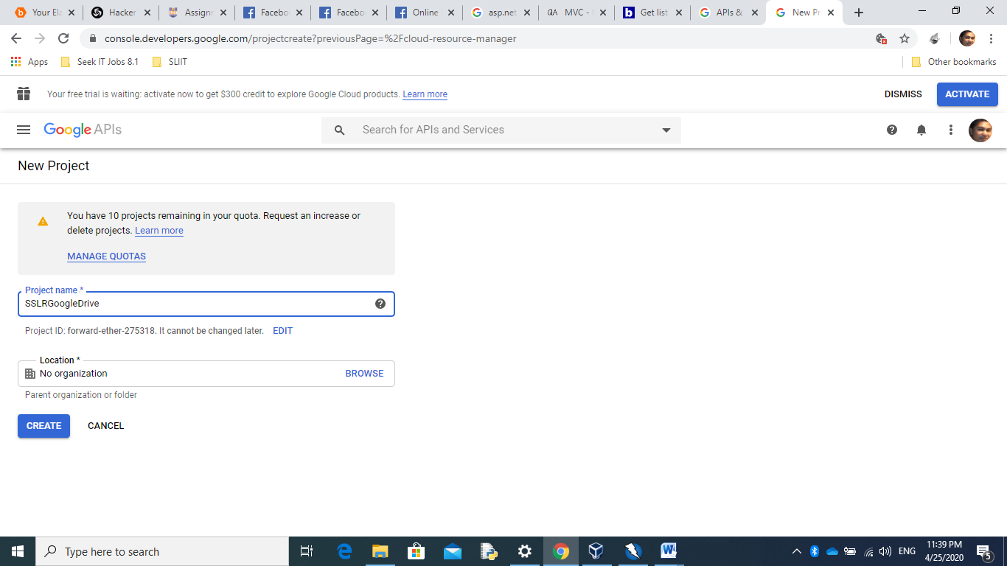

*Fig 1*: Create new Project on Google cloud platform

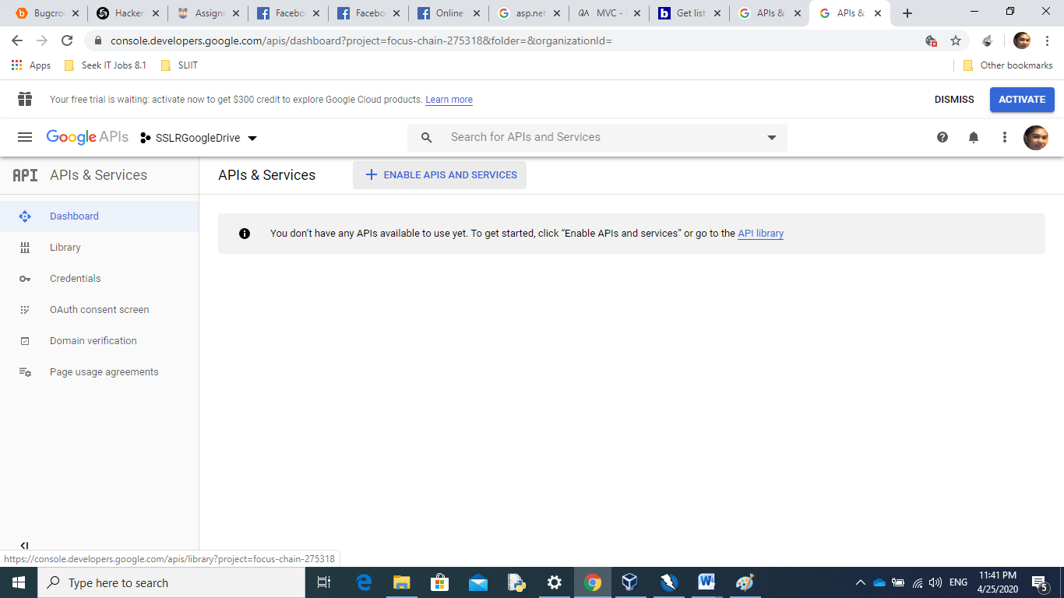

*Fig 2*:After Creare a new Project, Enabled Google Drive API for new project

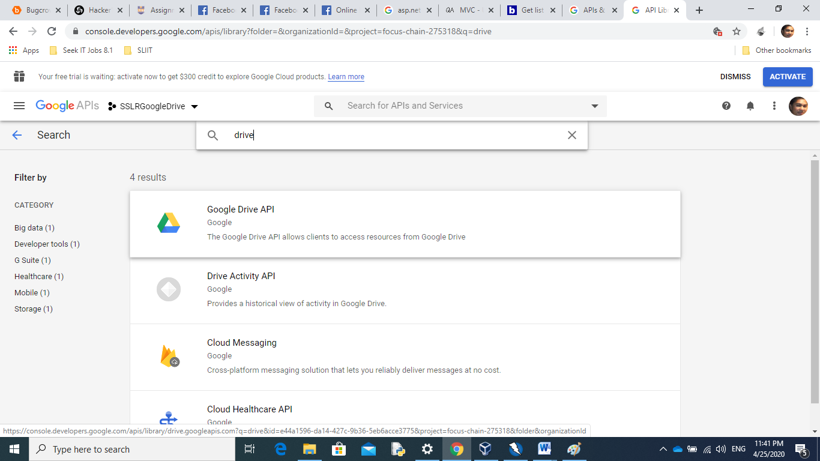

*Fig 3*: Add Google drive API to project

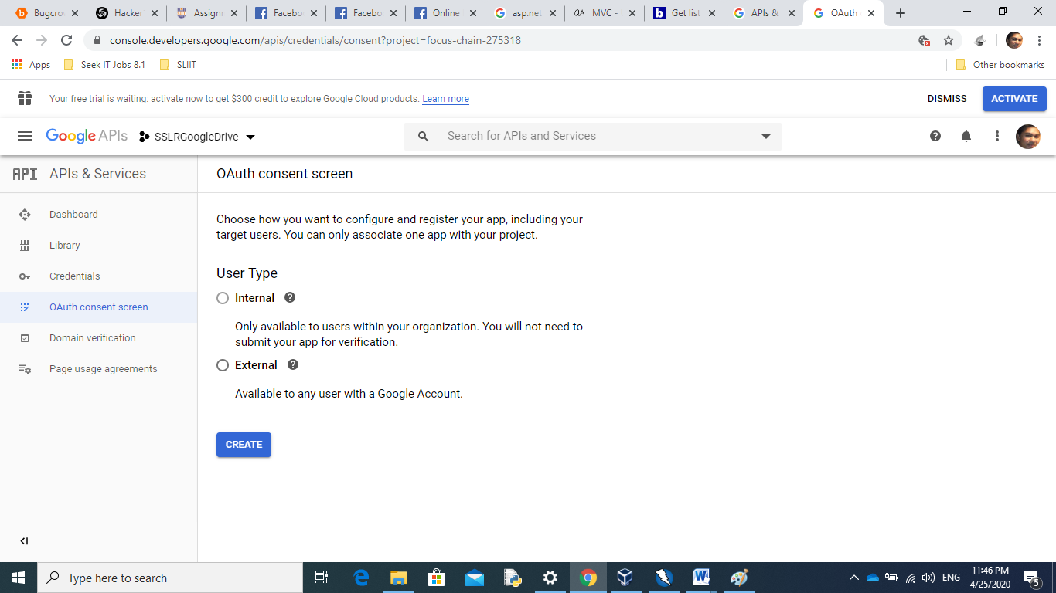From Oauth consent screen, “External user type” is selected to ensure that the application can use anyone who has a valid Google account.

*Fig 4*: Select user type as External for use it for any user with Google account

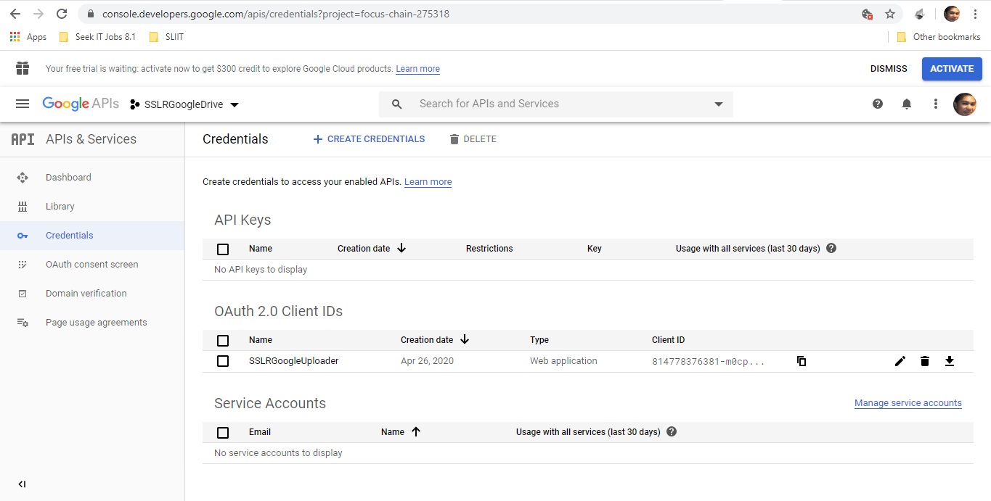

*Fig 5*: Create credentials

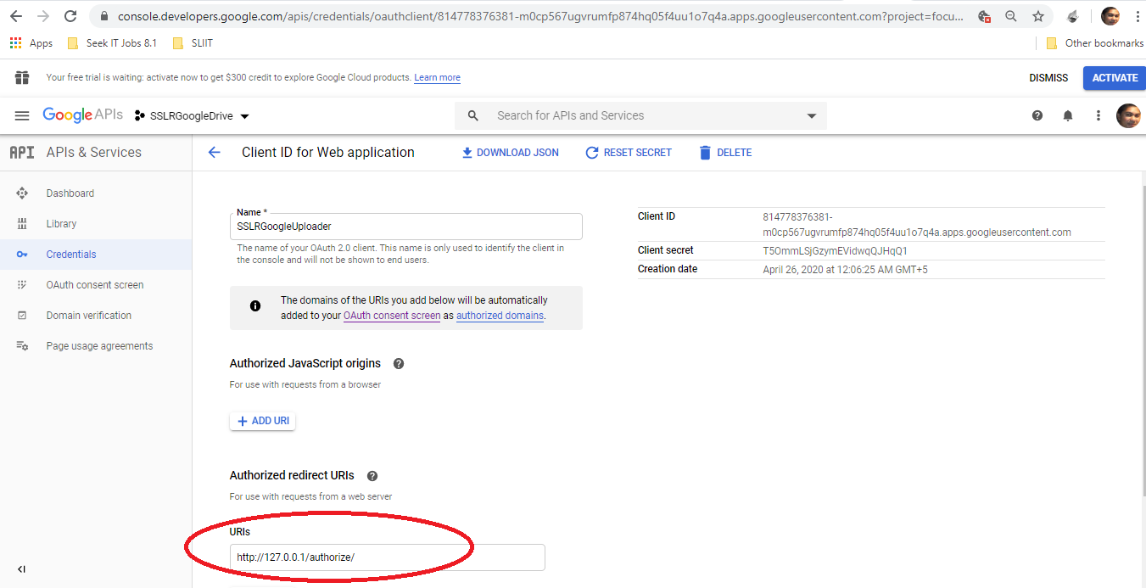

*Fig 6*:Set Authorized url to local for testing

After creating the credentials, client id and client secret codes are generated. The generated OAuth client details can be downloaded as a Jason file.

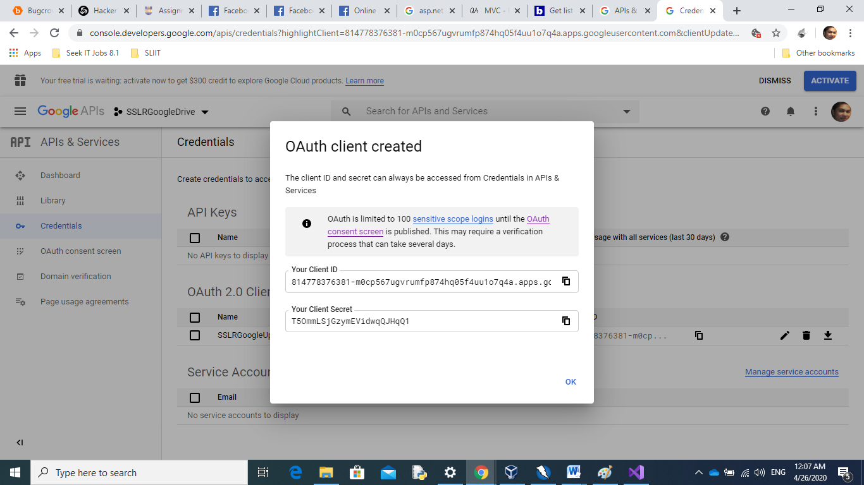

*Fig 7*:Download created OAuth client file as Jason file

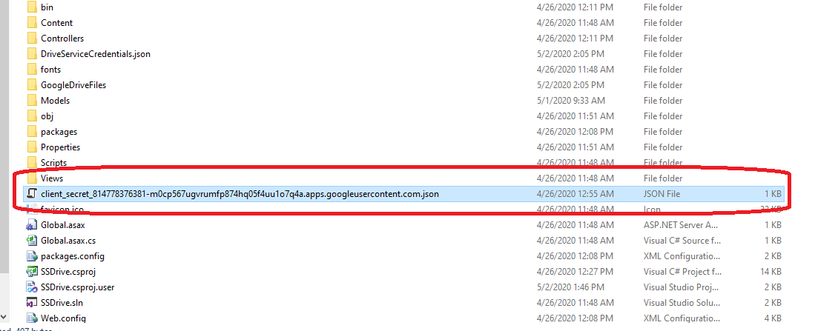

*Fig 8*:Downloaded Jason file this file contains

**Step 2 develop client side Application**

A web application is implemented as the client-side application. .Visual studio ASP.net and C#, MVC architecture is used for the application development.

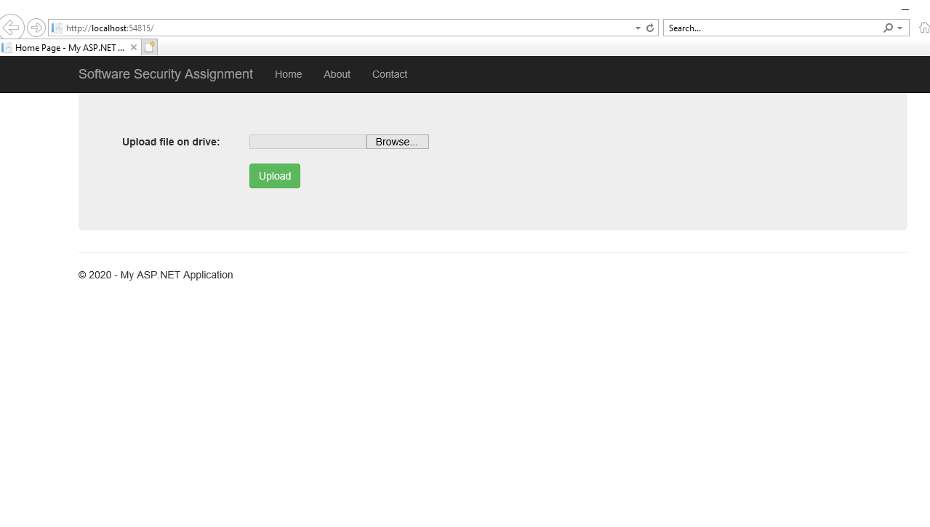*Fig 9*: Main interface-This interface consist with file browse option and upload button

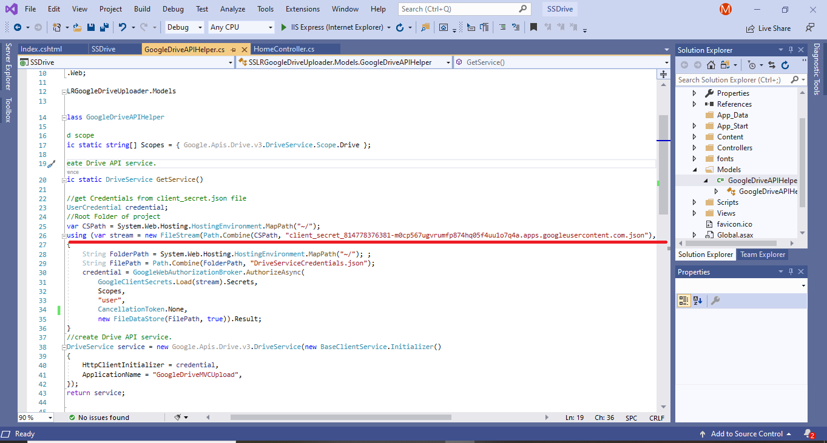

*Fig 10*: Created a new class and called Google OAuth by using downloaded Jason file

*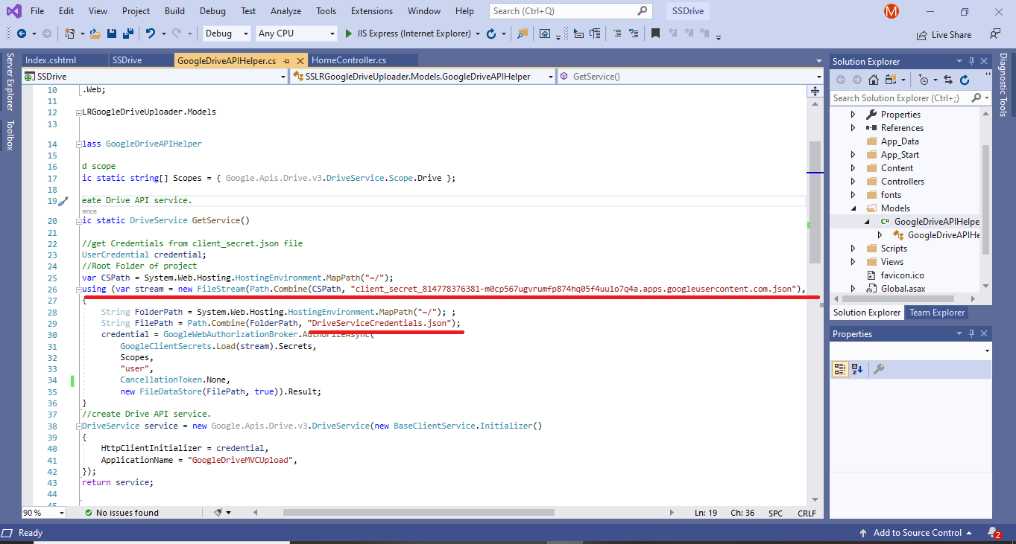Fig 11*: When calling oauth first check DriveServiceCredentials.json folder for access token

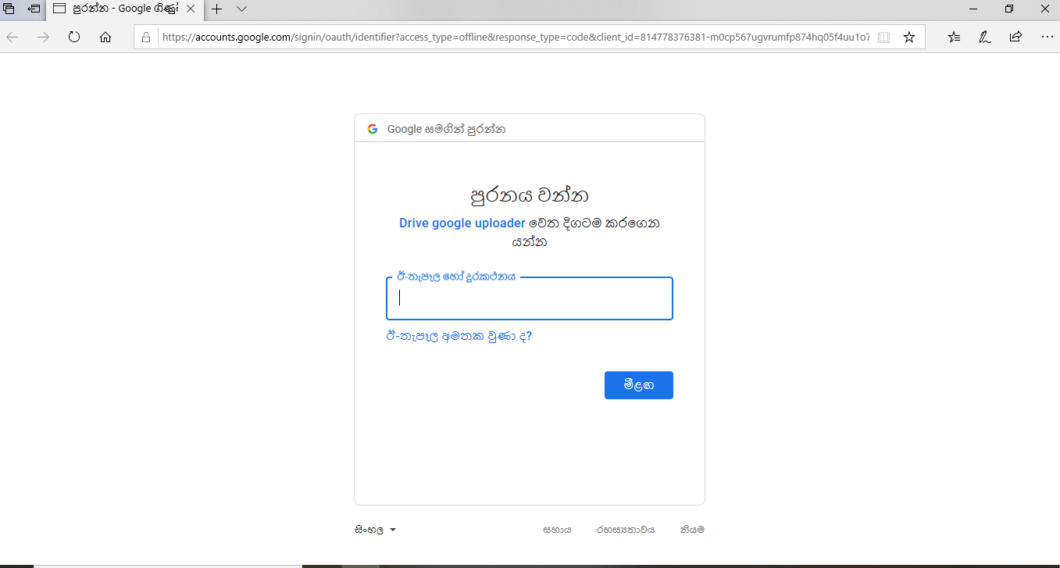

*Fig 12*: Redirect to Goggle OAuth page

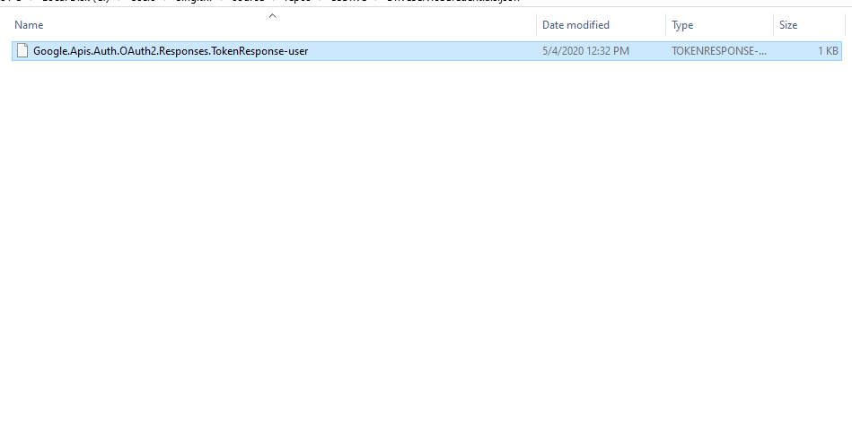

*Fig 13*: If Login successful Create access token in the user folder

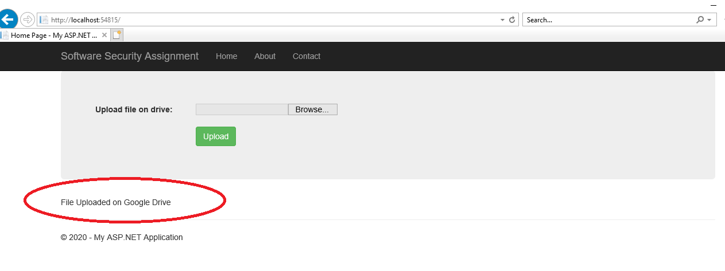

*Fig 14*: File Saved on Google drive

**3. Drawbacks**

If Access token released to public or third party anyone can access the or upload the files using same authorization.

**4. Conclusion**

Oauth 2.0 framework is providing more secure environment than normal client-server architecture for giving authorizations and permissions.

**5. References**

<https://oauth.net/2/>

<https://www.digitalocean.com/community/tutorials/an-introduction-to-oauth-2>

<https://developers.google.com/identity/protocols/oauth2>

<https://developers.google.com/identity/protocols/oauth2/web-server>

<https://medium.com/@munsifmusthafa03/building-a-file-upload-service-to-your-google-drive-using-oauth-2-0-d883d6d67fe8>

https://tools.ietf.org/html/rfc6749

<http://www.securityinternal.com/2017/04/retrieving-user-resources-from-facebook.html>

<http://www.securityinternal.com/2016/04/retrieving-user-profile-information.html>

<http://www.securityinternal.com/2016/06/java-web-application-for-retrieving.html>

**Appendix**

using Google.Apis.Auth.OAuth2;  
using Google.Apis.Drive.v3;  
using Google.Apis.Services;  
using Google.Apis.Util.Store;  
using System;  
using System.Collections.Generic;  
using System.IO;  
using System.Linq;  
using System.Threading;  
using System.Web;  
  
namespace SSLRGoogleDriveUploader.Models  
{  
    public class GoogleDriveUploader  
    {  
        //scope of class  
        public static string[] Scopes = { Google.Apis.Drive.v3.DriveService.Scope.Drive };  
  
        public static UserCredential HttpClientInitializer { get; private set; }  
        public static string ApplicationName { get; private set; }  
  
        public static DriveService GetAuth()  
        {  
            //Read from jason file  
                       
            UserCredential credential;  
            string crpath = System.Web.Hosting.HostingEnvironment.MapPath("~/");  
  
            var stream = new FileStream(Path.Combine(crpath, "client_secret_814778376381-m0cp567ugvrumfp874hq05f4uu1o7q4a.apps.googleusercontent.com.json"), FileMode.Open, FileAccess.Read);  
  
           
            String TokenPath = Path.Combine(crpath, "DriveServiceCredentials.json");  
            credential = GoogleWebAuthorizationBroker.AuthorizeAsync(  
                GoogleClientSecrets.Load(stream).Secrets,  
                Scopes,  
                "user",  
                CancellationToken.None,  
                new FileDataStore(TokenPath, true)).Result;  
  
            //API Create  
  
            DriveService Dservice = new Google.Apis.Drive.v3.DriveService(new BaseClientService.Initializer()  
            {  
                HttpClientInitializer = credential,  
                ApplicationName = "GoogleDriveMVCUpload",  
            });  
            return Dservice;  
  
  
        }  
  
        //upload drive to the google drive.  
        public static void UplaodtoDrive(HttpPostedFileBase file)  
        {  
            if (file != null && file.ContentLength > 0)  
            {  
                //call Auth  
                DriveService auth = GetAuth();  
                string path = Path.Combine(HttpContext.Current.Server.MapPath("~/GoogleDriveFiles"),  
                Path.GetFileName(file.FileName));  
                file.SaveAs(path);  
                var FileMetaData = new Google.Apis.Drive.v3.Data.File();  
                FileMetaData.Name = Path.GetFileName(file.FileName);  
                FileMetaData.MimeType = MimeMapping.GetMimeMapping(path);  
                FilesResource.CreateMediaUpload request;  
                using (var stream = new System.IO.FileStream(path, System.IO.FileMode.Open))  
                {  
                    request = auth.Files.Create(FileMetaData, stream, FileMetaData.MimeType);  
                    request.Fields = "id";  
                    request.Upload();  
                }  
  
  
  
            }  
        }  
    }  
}